https://wolterton.co.uk/product/drawing-with-confidence-a-guided-workshop/
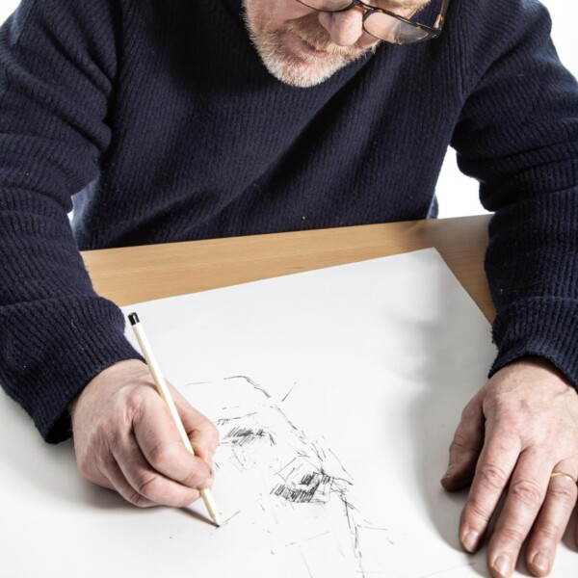
Drawing with Confidence: A Guided Workshop
Event Date: Wednesday, 8th April 2026 10:00 AM – 1:00 PM
Enhance your drawing skills in a friendly and relaxed workshop with local artist and teacher Matthew Phelps, set in the picturesque surroundings of Wolterton. Designed for those who already enjoy drawing and want to take their abilities to the next level, this workshop focuses on refining techniques, exploring new approaches, and nurturing your artistic confidence. Matthew will offer personalized guidance, helping you develop your style, improve observation, and tackle more challenging approaches to drawing. Surrounded by the beauty of Wolterton, you’ll find inspiration around every corner while enjoying a supportive, creative environment that encourages experimentation and growth in your artistic journey.
£45.00
Details
Matthew Phelps is well known Art and Design teacher in Norfolk, known for his work at Paston College in North Walsham where he’s been Head of the Arts Faculty, inspiring students and integrating contemporary art into the curriculum. He’s also a practicing artist, creating paintings, drawings, and sculptures, and is recognized by art platforms like Highgate Contemporary Art for his artistic background and life in Norfolk.
All materials provided including coffee, cake and refreshments throughout the morning! If time permits we offer a guided tour of the Hall and gardens after the drawing class.

